Guinea

## Freedom House political status

The data set shows the Freedom House political scores and status of the country each year.

## # A tibble: 19 x 5  
## country iso3c date mean status   
## <chr> <chr> <dbl> <dbl> <chr>   
## 1 Guinea GIN 1996 5.5 Not Free   
## 2 Guinea GIN 1998 5.5 Not Free   
## 3 Guinea GIN 2000 5.5 Not Free   
## 4 Guinea GIN 2002 5.5 Not Free   
## 5 Guinea GIN 2003 5.5 Not Free   
## 6 Guinea GIN 2004 5.5 Not Free   
## 7 Guinea GIN 2005 5.5 Not Free   
## 8 Guinea GIN 2006 5.5 Not Free   
## 9 Guinea GIN 2007 5.5 Not Free   
## 10 Guinea GIN 2008 6 Not Free   
## 11 Guinea GIN 2009 6.5 Not Free   
## 12 Guinea GIN 2010 5 Partly Free  
## 13 Guinea GIN 2011 5 Partly Free  
## 14 Guinea GIN 2012 5 Partly Free  
## 15 Guinea GIN 2013 5 Partly Free  
## 16 Guinea GIN 2014 5 Partly Free  
## 17 Guinea GIN 2015 5 Partly Free  
## 18 Guinea GIN 2016 5 Partly Free  
## 19 Guinea GIN 2017 5 Partly Free

## Freedom House classification of political change

The data set shows the GDP growth and the ecomic growth classification of the country each year.

## # A tibble: 19 x 4  
## country iso3c date politicalChangeFH  
## <chr> <chr> <dbl> <chr>   
## 1 Guinea GIN 1996 no change   
## 2 Guinea GIN 1998 no change   
## 3 Guinea GIN 2000 no change   
## 4 Guinea GIN 2002 no change   
## 5 Guinea GIN 2003 no change   
## 6 Guinea GIN 2004 no change   
## 7 Guinea GIN 2005 no change   
## 8 Guinea GIN 2006 no change   
## 9 Guinea GIN 2007 no change   
## 10 Guinea GIN 2008 autocratization   
## 11 Guinea GIN 2009 autocratization   
## 12 Guinea GIN 2010 democratization   
## 13 Guinea GIN 2011 no change   
## 14 Guinea GIN 2012 no change   
## 15 Guinea GIN 2013 no change   
## 16 Guinea GIN 2014 no change   
## 17 Guinea GIN 2015 no change   
## 18 Guinea GIN 2016 no change   
## 19 Guinea GIN 2017 no change

## Freedom House score trend

The plot shows the Freedom House scores trend of the country.

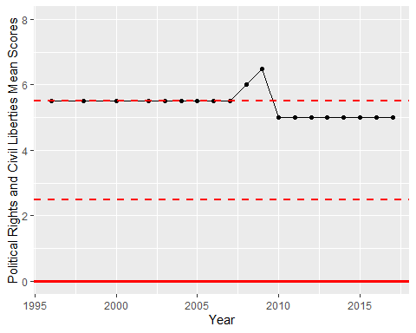

Freedom House Score Trend